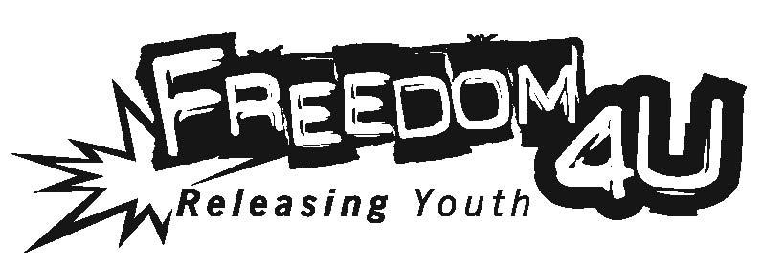

Nov. 11, 2017

Dear Freedom4U Supporter,

On Sunday afternoon, April 22, 2018, Freedom4U will present Freedom Breeze, a fundraiser event to benefit our youth programs. This exciting evening held at a beautiful private residence in Palos Verdes Estates, features live music, inspirational youth performances, silent and live auctions and a variety of special foods and drinks. This event will be promoted to the entire South Bay and LA Harbor community.
Freedom Breeze is a great opportunity to show your support for the youth we serve.

Freedom4U is a non-profit organization providing meaningful programs in creative arts, life skills, leadership and service to youth for fifteen years. We offer a variety of programs to help youth develop and share their talents, form healthy and safe relationships and reduce risky behaviors. Your support will benefit the following programs:

- After school programs located at schools and in the greater South Bay/LA Harbor community.
- Drug and alcohol abuse prevention programs.
- School-based counseling services for at-risk youth at several schools.
- Programs promoting creative arts and expression of talent such as Jazz Expression, The Awakening, Music Nights, songwriting & music improvisation workshops, annual film, South Bay Idol and photography contests.
- Life Skills Workshops (GirlWise & WiseGuys) to facilitate development of healthy relationships, responsible decision making, goal setting and improving school performance.
- Career Path workshops and groups aimed at identifying possible passion and purpose for life.
- Small groups aimed at healthy relationships, social fun and inspiration for life.
- Resources for parents including classes and seminars on parenting, decision making, youth stress management and other topics.
- Development of peer mentors in our Youth Leadership Service-Learning Group.

Please consider donating and item or service for our auctions, or a cash donation. A description of your item(s) and an acknowledgment will be listed in the Freedom Breeze online catalog distributed to families and businesses. Auction donors will also be included in a Thank You E-blast to our entire email community. Your donation may also qualify you to receive Freedom4U Business Partner benefits (see the enclosed donation form for all benefits or with our electronic donation form at www.freedomcommunity.com.)

Thank you again for your consideration of our request. To become a donor, please contact us by March 2, 2018. If you have any questions, please contact Dr. Greg Allen, Director of Freedom4U, at (310) 897-5043 or greg@freedomcommunity.com. For more information about Freedom Breeze go to www.freedomcommunity.com

On behalf of our kids,

Greg Allen

Dr. Greg Allen, Freedom4U Director
336 Tejon Place, PVE, CA. 90274
839 S. Beacon St., #1620, SP, CA. 90731
Tax ID#82-0542176

